Work
Work done is defined as product of the force and the distance over which the force is applied.
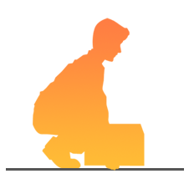
Work is done when a force is applied to an object and the object is moved through a distance.

For example, when you lift a load you are applying a force over a distance so you are doing work.
When you push a shopping trolley around a supermarket you are applying a force over a distance, therefore you are doing work.

When a car is moving on a motorway, a force is being applied over a distance and work is being done.
Work done: = force x distance
W = F x s
W is measures in joules.
F is measure in newtons.
s is measured in metres.
When work is done, energy is transferred.
Example questions:
Question 1
A fork lift moves 34m carrying a 1023N box across the warehouse floor. How much work is done by the fork lift?
Answer:
W = F x s
W = 1023N x 34m
W = 34,782 J The forklift does 34,782J of work.
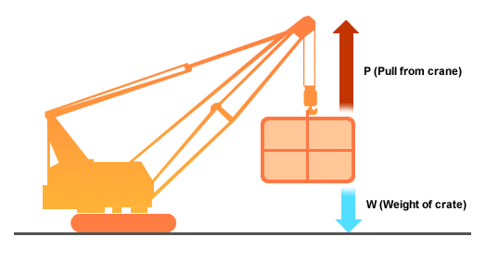
Question 2
A crane operator on a building site slowly raises a loaded crate of mass 1500 kg at a steady speed.
a) What is the weight W of the crate?
b) What is the upwards pull P on the crate?
c) How much work is done by P in raising the crate to a height of 4 m?
d) What is the gain in gravitational potential energy of the crate when it is at a height of 4 m.
e) What is the gravitational potential energy of the crate when it is a height of 9 m?

Answer
a) The gravitational pull acting on a mass of 1 kg is 9.8 N.
So the gravitational pull on a mass of 1500 kg is 1500 x 9.8 = 14 700 N
Weight of loaded crate = 14 700 N
b) Upwards pull P = weight of crate = 14 700 N
c) Work done by P in raising crate to a height of 4 m
= force applied to crate x distance moved
= 15 000 x 4
= 60 000 J
d) Work done by P in raising crate to a height of 4 m
= gain in gravitational potential energy
So, gain in gravitational potential energy = 60 000 J
e) Gravitational potential energy, E_{p}= mgh
= 1500 x10 x 9
= 135 000 J
Gravitational potential energy of the crate at a height of 9 m = 135 000 J

Practice Problems:
1. Calculate the amount of work done when moving a 567N crate a distance of 20 meters.
2. A fallen tree of mass 700kg lifted 2.75 meters. How much work is done?
3. If it took a bulldozer 567.6 joules of work to push a mound of dirt 30.5 meters, how much force did the bulldozer have to apply?
4. A frontend loader needed to apply 137 newtons of force to lift a rock. A total of 223 joules of work was done. How far was the rock lifted?
5. A young boy applied a force of 2,550 newtons on his St. Bernard dog who is sitting on the boy's tennis shoes. He was unable to move the dog. How much work did he do trying to push the dog?
6. If it takes 68 joules of work to push a desk chair 3m across a floor, what force would be needed?
7. If a long distance runner with a weight of 596.82 newtons does 35,674.7 joules of work during a portion of a race, what distance will she cover during that portion?
8. If a weight lifter raises a barbell with a mass of 125.7 grams doing 5,023 joules of work, what distance did he move the barbells? Remember that you need a force, not a mass. You must first calculate the force in order to complete your solution. HINT: Weight is a force. Weight on earth is determined by multiplying an object's mass times earth's gravitational pull (9.8m/s² ).
9. Children are sled riding on a hill. One little girl pulls her sled back up the hill and does 379.5 joules of work while pulling it back up the 17.3 meter hill. What amount of force did she exert on the sled?
10. A large semi-truck is moving a house from one lot to another. The amount of force required to move the house horizontally a distance of 73.2 meters is 3,500 newtons. How much work will be done on the house?

